Digital Timer Font: (If we decide to use the digital timer)

<https://www.dafont.com/ds-digital.font?back=top>

While looking at other games with a similar art style I found that for UI the types of fonts generally used where easy to read sans serif comic fonts, with some games occasionally using more angular fonts

E.g. **Comic Sans –** However we won’t use comic sans…

I found a number of sans serif comic fonts which would work well on UI

<https://www.dafont.com/multicolore.font> 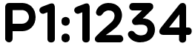 - This font would could very well for the players score as it is very easy to read. In my opinion the P in this font is a little too wide however that could be changed. A down side of this font is that it only contains uppercase letters so it would not look good for text heavy areas, e.g. tutorials or menus

<https://www.dafont.com/simply-rounded.font> https://i.gyazo.com/240c191f5708fb735c49d4f5365198ab.png - this font when made bold could also be used for scores however this font also has lowercase letters and due to being similar it could be used alongside the first font without being too off-putting (E.g. player 1)

<https://www.dafont.com/be-kind-to-the-earth.font?back=theme> https://i.gyazo.com/bb1b54ab52844dec5edd16bf7dd0b380.png- This font has a hand drawn effect to it which may make it harder to read, however the less preciseness of this font may fit our game, due to its less accurate writing style I don’t think it’d be used for the players score however for other aspects it may be suitable, this font or a similar font could also work well for a title if it was edited for that purpose.

<https://www.dafont.com/pointfree.font> - This font is also not as easy to read and also has a handwritten theme, a font like this would not work well as it is now and may need editing e.g. a border could be applied to it

<https://www.dafont.com/simple-dandy.font> 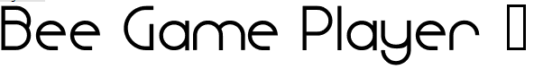 - This font lacks number images and thus it is unusable for scores and the some letters look too modern for our type of game. A font like this would be a poor choice for our game normally however it may fit aspects.

<https://www.dafont.com/bpreplay.font>  - This font is similar to the first few fonts I found and thus it would be suitable for the same purposes however when looking at this page this font stands out the most and is the only font I’ve found so far which passes the squint test, because of this; this font might be very suitable for a title or other aspects which are important to note (Such as the next player display)

<https://www.dafont.com/kg-a-teeny-tiny-font.font?text=Bee+Game+Player+1&back=theme> 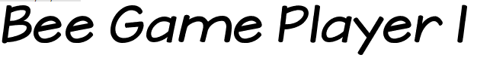 - The font is reminiscent of the third font I found, in the way that it looks hand drawn however with the exception of the number at the end I think this font is easier to read that that font, because of this it may be more suitable for things like menus, however due to the challenge in reading the number it will not be suitable for the player number or score.

<https://www.dafont.com/alpha-bizzy-bee.font?text=B>  - I do not consider this font usable in the slightest due to its difficulty in reading and it not being taken seriously however for our title we could do something similar, we could have the bee from our game appear as a character in the title, other things we could do is if the title contains an I we could replace the dot with one of the pickups amongst other stuff, this type of font design is not good for reading however it can be very recognisable and thus it might be suitable for the games logo.